TAIR Qualtrics Workshop

Outline:
How to create surveys
- Sections
- Question types
- Automatic choices
Setting up the look and feel of your survey
Distributing Surveys
Reminders
Results
- Qualtrics generated reports
- Parsing results
Qualtrics Libraries
Housekeeping Issues
- Renaming
- Deleting responses

Anyone can create free account once at http://www.qualtrics.com. Free trial accounts have the following:
- 100 total responses
- 10 outgoing emails
- 1 active survey
- 4 question types (descriptive text, multiple choice, matrix table, text entry)
- Free account branded survey themes

- Download data
- Report sharing
- Email triggers
- Translate survey
- Conjoint
- Table of contents
- Screen-out
- Cross tabs
- Salesforce Integration
- HTML/Javascript

This should allow them to follow along with basic tasks, however they won't have access to more advanced features or the full set of question types.

The initial environment: 2 choices for view
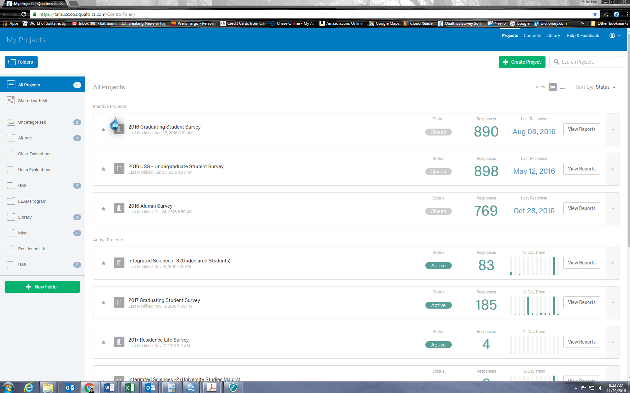

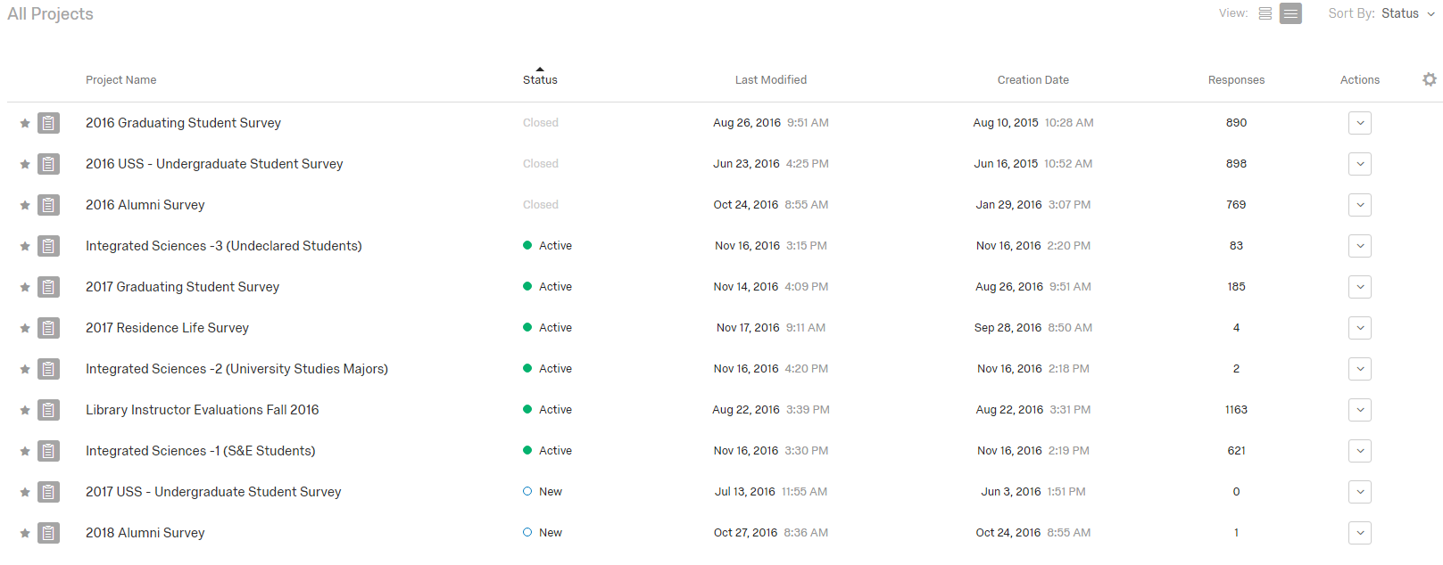
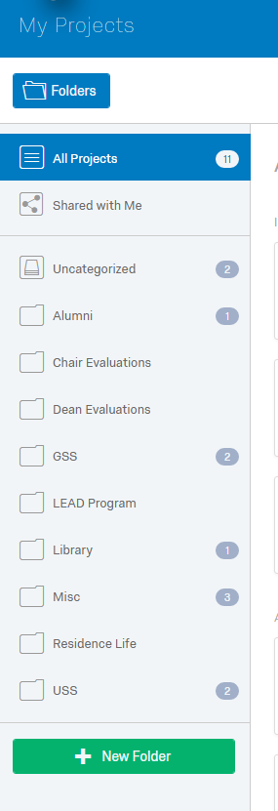 (detail) 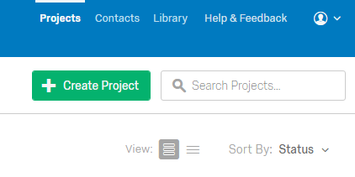
Creating Projects (Surveys) Click Create Project
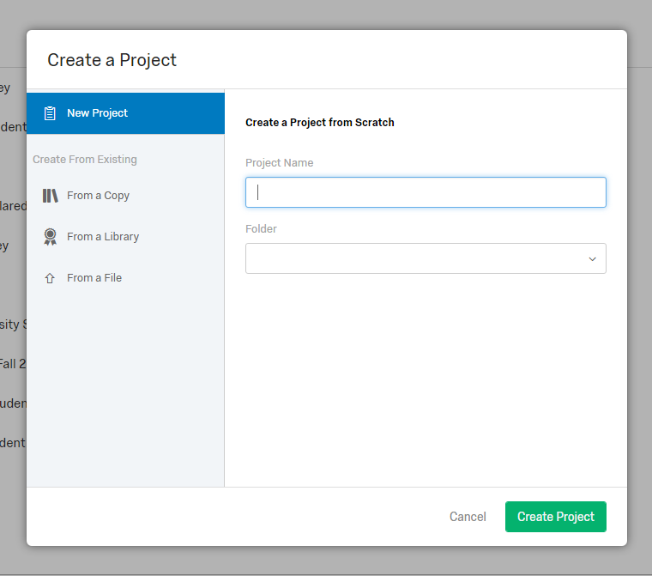 Choose New or From a Copy or Library.
Give it a name and select the folder to store it in.
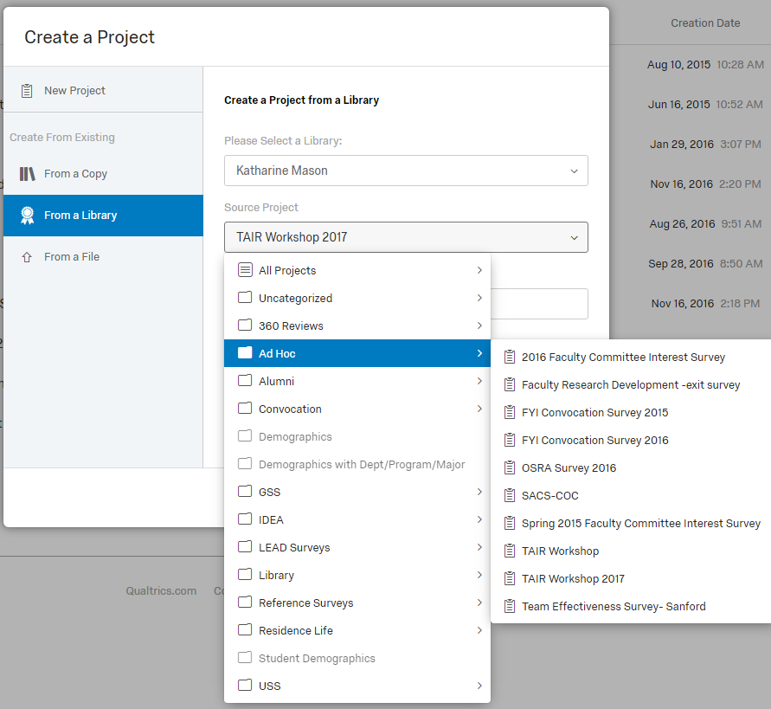

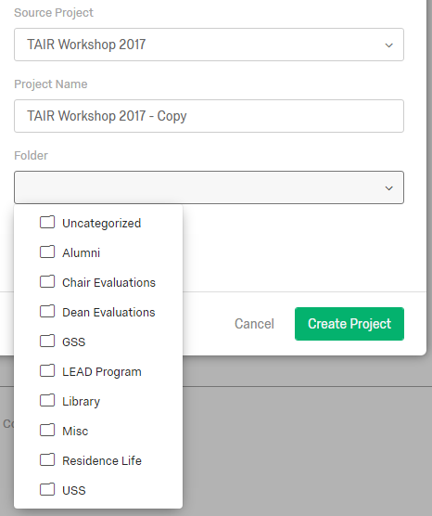

Once you have named your project you are ready to start building your survey. Insert an introductory paragraph by clicking on Create a New Question. Then choose the question type Descriptive Text.

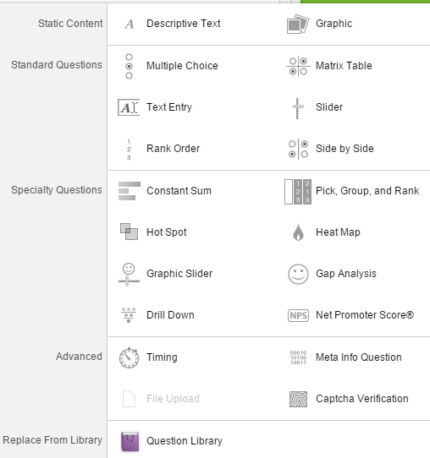

Note - if you hover over a type of question it will come up with an example.

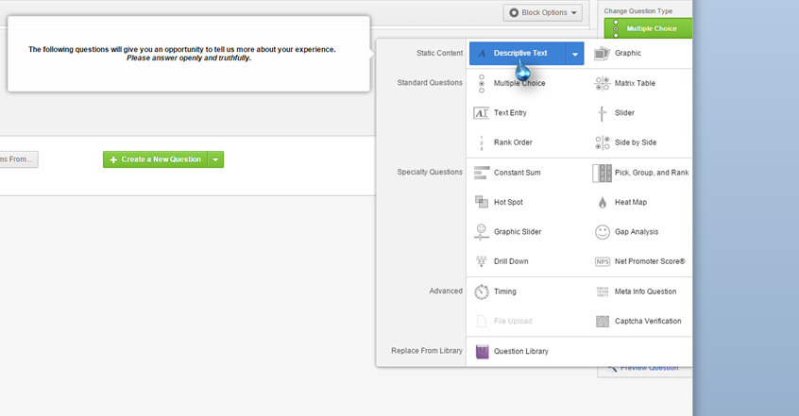

The blue arrow points to the description and an example.

Types of Questions
Descriptive Text:
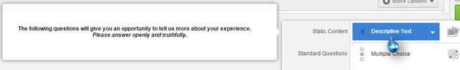
Use the descriptive text option for an introductory area to describe the purpose of your survey, what the information gathered will be used for, anonymous/confidential information if applicable, and contact information for the person doing the survey in case there is a glitch.
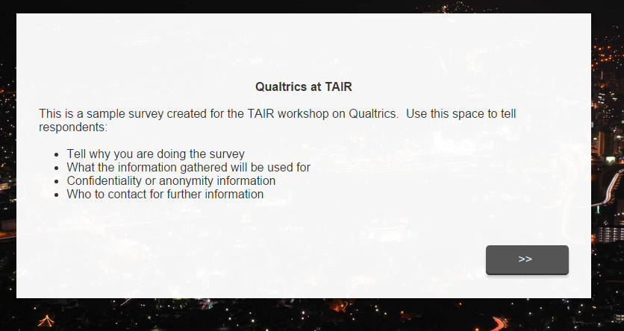

A Matrix Table is a Likert scaled item.
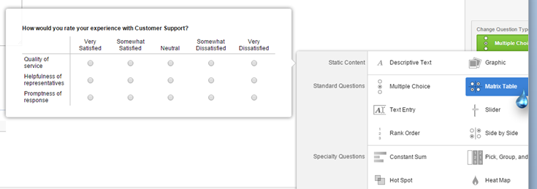
Selecting Automatic Scale Points:

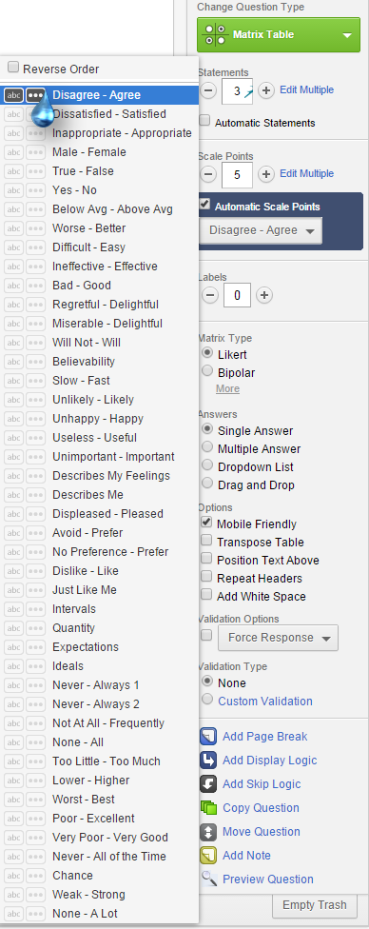

You can select the number of statements and the number of scale points. There are many options to choose from. You can also select “reverse order” at the top to put the choices in descending order.

A related type of question that is useful if you want to ask two questions about the same item is the Side by Side. 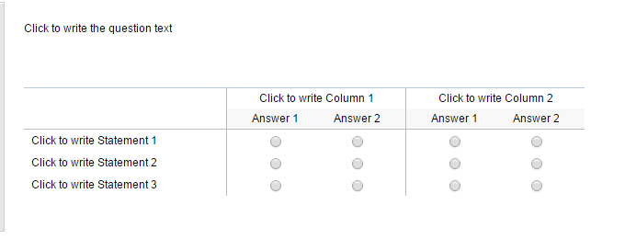

Text entry allows for open-ended questions where you can choose the size of the box available to write in; the choices are single line, multi-line, or essay text box.

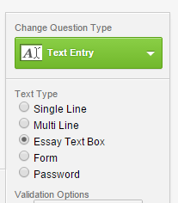

In the option panel under Text Entry choose the size of the box for the response.

The Slider option allows for an enhanced user experience where they can physically move the indicator.
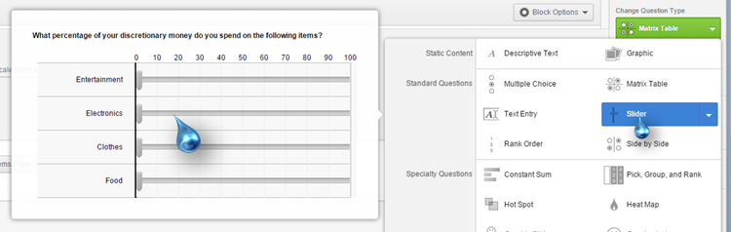
Rank Order allows respondents to rank order items in a variety of manners such as graphically, drag and drop, and selection box
Graphically –
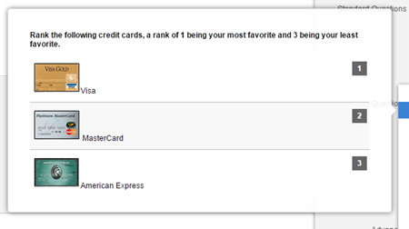
Drag and drop-
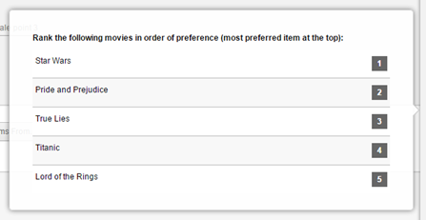

Selection box (where you use arrows to move the choice up or down)-
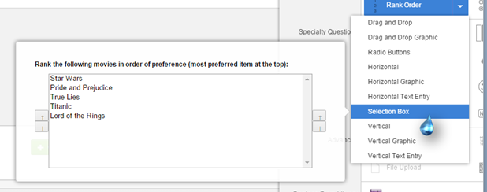
Specialty Question Choices:
Constant Sum-
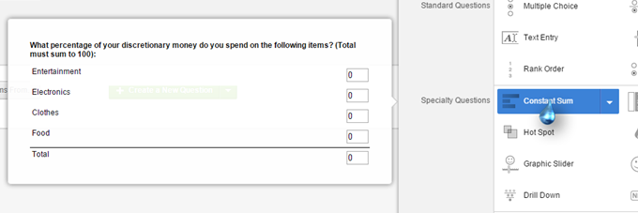
Pick, Group, and Rank-
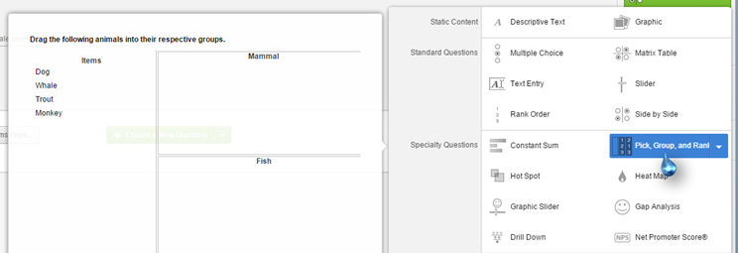

Hot Spot-
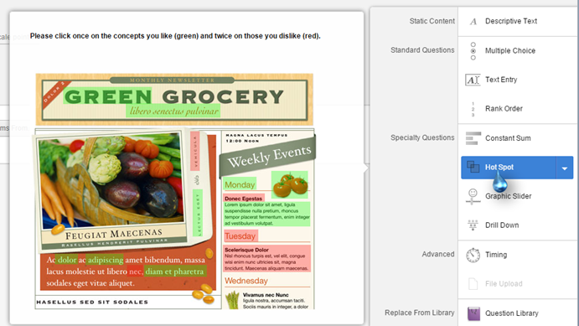
Heat Map-
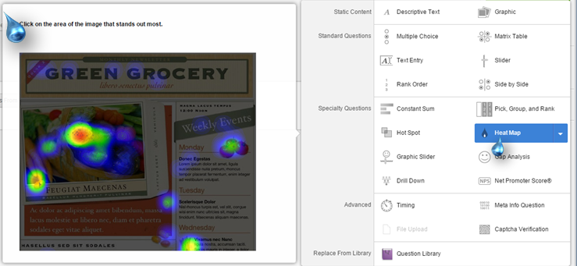

Graphic Slider-
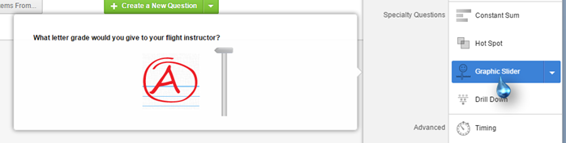

Gap Analysis-
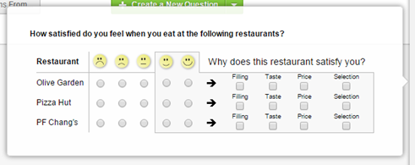

Drill Down-

Net Promoter Score-
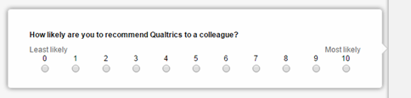

Display Logic

This feature allows you to display questions to only some respondents the question pertains to; it is not shown to people the question is not relevant to. For instance I ask students what department, program, or major they are in. Rather than list all departments, programs, and majors from the entire university, I am able to show them the appropriate list according to the College they selected in the previous answer.
First select the question that will only be displayed to some respondents. In the menu choose Add Display Logic.
Select the question where respondents made a choice (for my example, college).
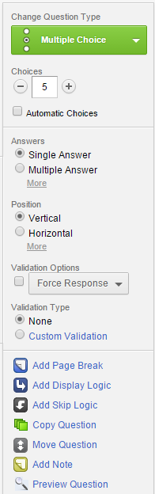

You can also access this by clicking the down arrow on the gear symbol under the question number.
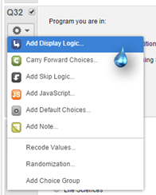

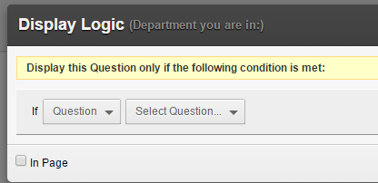

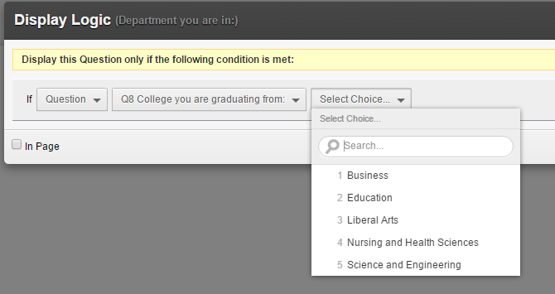

Then choose the option for the question you want shown only to the respondents that chose that option. Click Save.
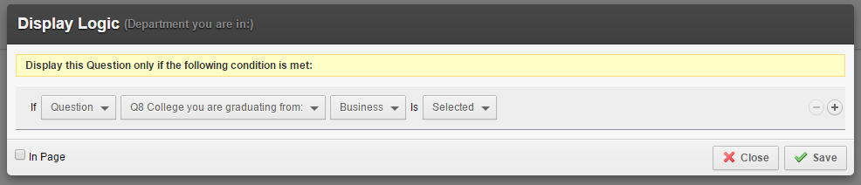

For my example, I am able to use the display logic choice of Business in the College you are graduating from question for the subsequent department, program and major questions. I then set this up for all the colleges, their departments, programs, and majors.
Branching
Branching is used when you have a more complicated situation than just a couple of questions that you only want some people to see. I use branching when I have a survey, for instance our Comprehensive Library Survey that includes faculty, staff, and students. There are different demographic questions for each group, but the questions about the library are the same.
The branching directions below were copied from Qualtrics help at: http://www.qualtrics.com/university/researchsuite/advanced-building/survey-flow/branch-logic/
Branches are created in the Survey Flow, like a Block or Embedded Data.

To add a Branch:
- Click Add below or Add a New Element Here.
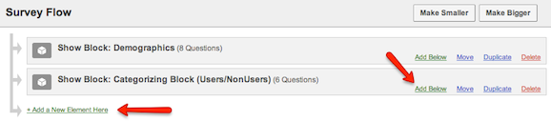
- Click Branch.
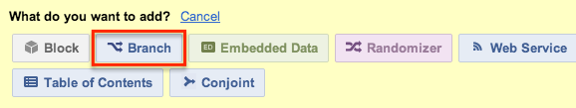
- Click Add a Condition and add a logic condition. Branch logic conditions can be based on questions, Embedded Data, Quotas, or GeoIP Location. For more information on setting logic conditions, see Using Logic.
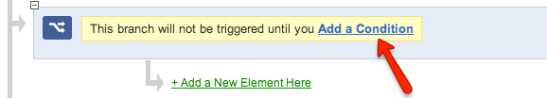
- Create a new element or move an existing one underneath the Branch.
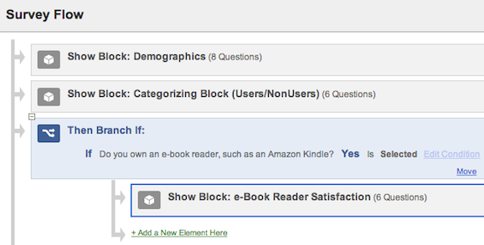

Below is what the survey flow looks like for my Comprehensive Library survey.
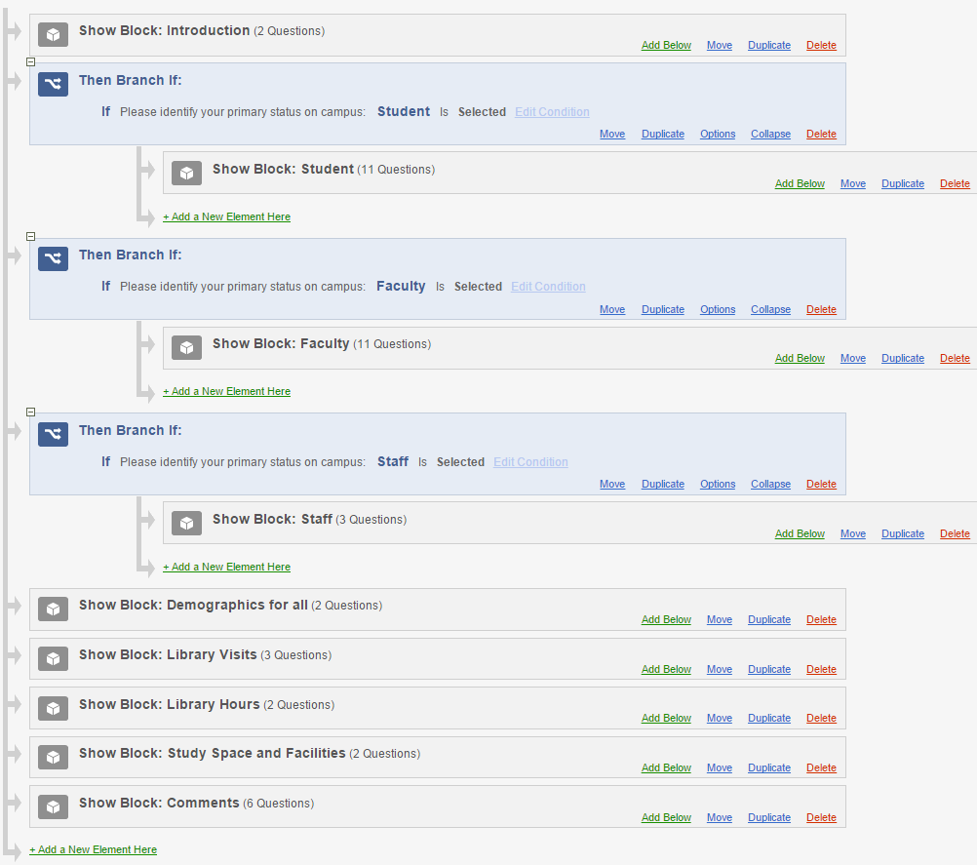
Technical Set-up
Look and Feel page:
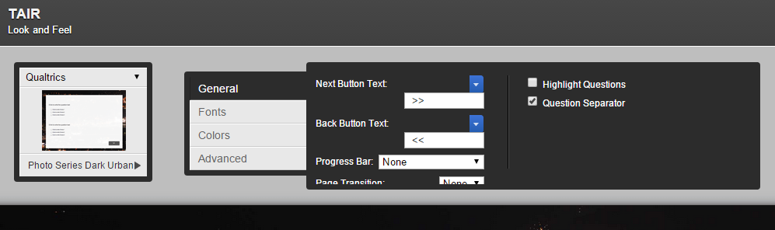
Click the choices you wish for Next and Back button text. You can play around with Fonts and text colors if you wish. You can also select a Page Transition like slide, flip, or fade if you have a lengthy survey. It is not an option for short surveys.
I like to select the Highlight Questions as it puts a different background color behind the question they are working on.
I normally like a photo background; select one of the limited choices by clicking on the right-facing arrow indicated by the blue arrow in the example above.

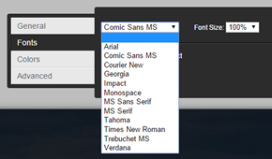

If you use a photo background, you cannot change colors, but you can change font type.

In the Advance tab you can put in a header or footer.
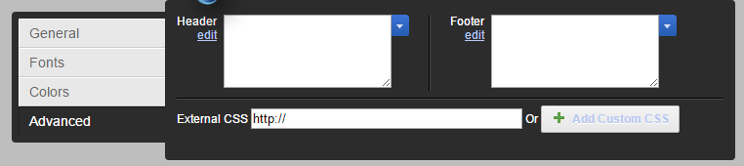

Survey Options page:
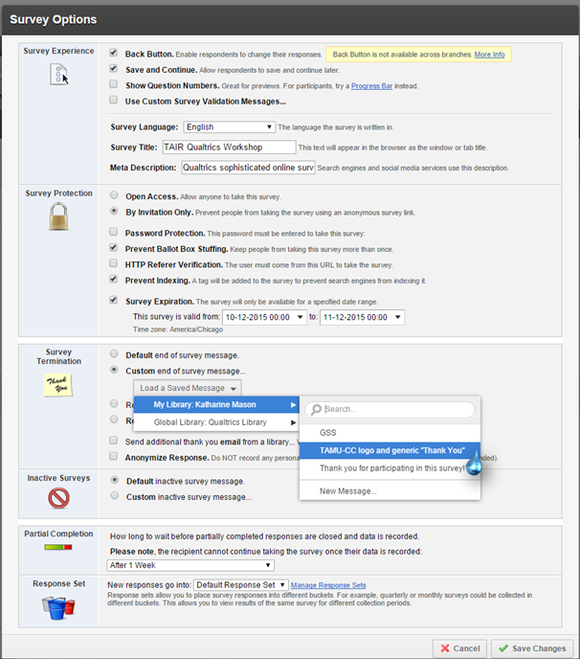

The blue arrows point to useful items to check for surveys you are sending out to email addresses.
To create a custom end of survey message, simply click on New Message. A dialogue box will open where you can put in your message, with a graphic if you choose.
Distributing Surveys
There are several options, but the two most common are anonymous and sent by email.
If your survey is set up to be anonymous and taken by anyone, you need only distribute the URL found when you click Get a single reusable link.
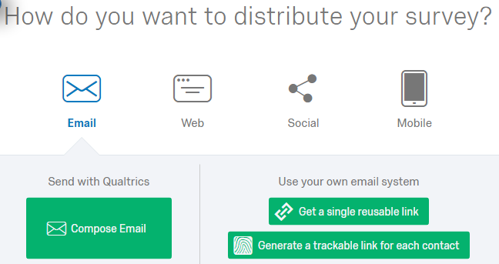

A URL is then shown that you can distribute to respondents.
You can always find the link by going to the Distributions tab. (below)
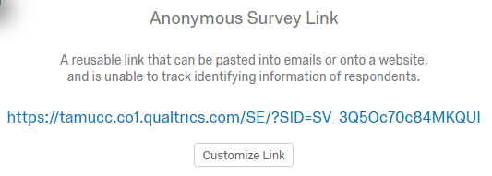

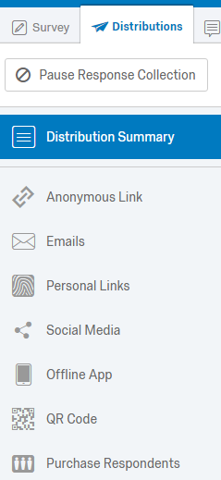
Sending Surveys by Email
Click on the Emails option on the Distributions tab.
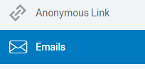 You will see this. 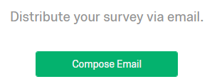

Then you will see this page: Note - we are unable to change any of the “from info”. Ours are always labeled FROM: TAMUCC Survey.
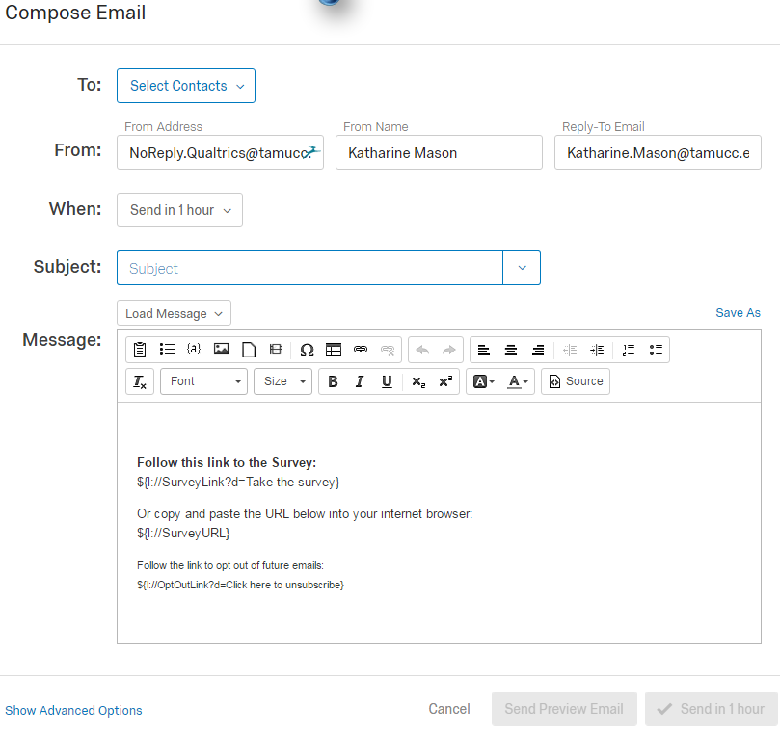
I’ll cover putting the panel in shortly. The other things to fill in on this page are the subject line, when to send (many options), and the message. For the best look when the respondents get the invitation, use the Font and Size options to make the message 12 point Times New Roman.
In the body of the message I put an introductory paragraph explaining why they are included as a respondent, the purpose of the survey, and what the data will be used for in front of the Follow this link statement. I then insert a few blank lines and put a closing Thank you message along with my contact information before the Opt Out statement. I also insert a few more blank lines before the Opt Out statement.
You must save the message before it can be sent. It is good practice to label as you go along, so create a folder to put the message in with a useful title. It is also good practice to send a test message to yourself to make sure the invitation displays nicely. This practice also helps to catch message errors.

Selecting Contacts
On your My Projects page, in the upper right hand corner there are these options.
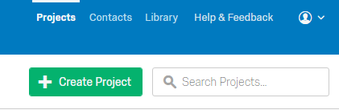 Click on Contacts to create your contact list.

Then click on Create Contact List.
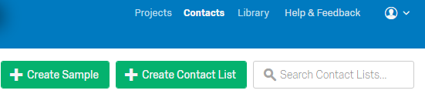 Then name it & select folder.
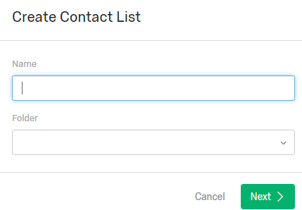 Then you will see a dialogue box where you can import a file.
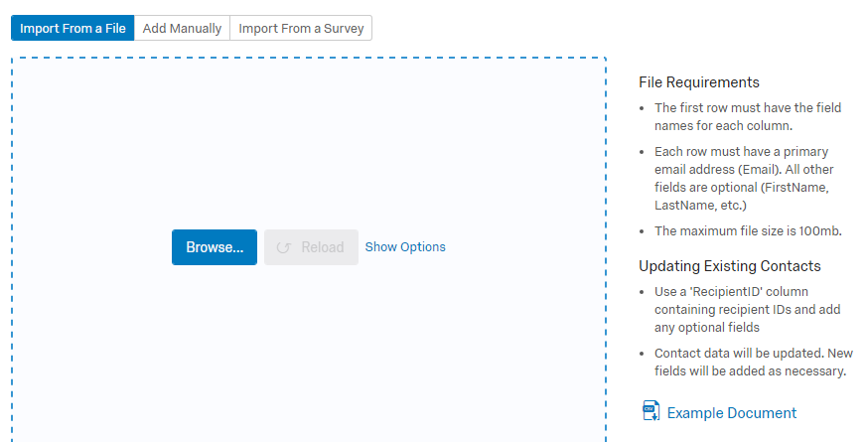

Very Important!
Must create excel file in CSV format!
Cannot use a salutation with a period, must only be first or last name.
Add other columns using headings spelled FirstName, LastName, and any other heading you need.

Do check out their example document to make sure you get it right.
For more detailed instructions, refer to the handout from me titled Creating a Contact List.

Personalized Messages (Inserting Fields)
Research has shown that personalizing a message by inserting the recipient’s name yields higher response rates. This is easily done as long as you have the fields for the name you want to insert next to your list of email address in your excel worksheet.

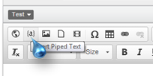
After you select the braces symbol (curly parenthesis) shown above, you then need to select what you want to insert. In this case, I want to insert the recipient’s first name. So I click that selection from the list.
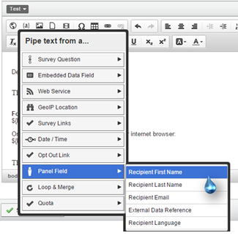

Tip and Trick
In the following example the recipient’s first name is used. Then, on the excel worksheet the instructor’s last name was put in a “lastname” column after the student information. Because of this, I was able to insert the instructor’s name in the appropriate place in the message. Typically Recipient Last Name would mean the last name of the person you are contacting, but for this purpose (sending a message to a particular student in a particular person’s class) you can use the function for another purpose. By doing this, you are able to send a more personalized message.
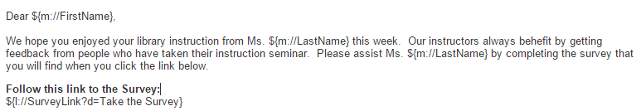
Notice that ${m://FirstName} is what appeared when I selected Recipient First Name. But also notice that in the example there is a comma after the ${m://FirstName}. You must remember to punctuate as you normally would in your script.

Sending reminders
To send reminders go to the Emails link on the Distribution Summary page.
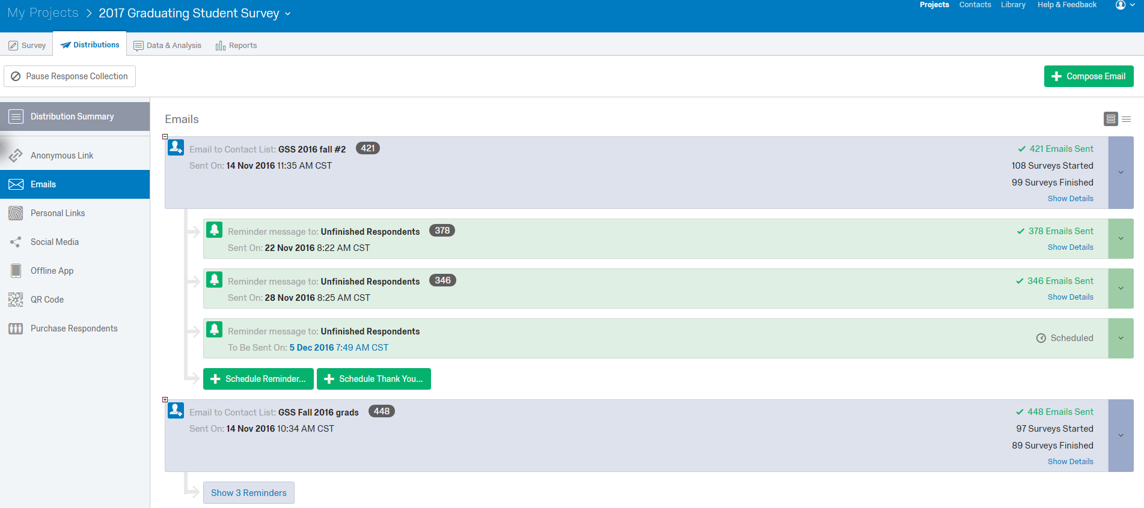

Close ups:
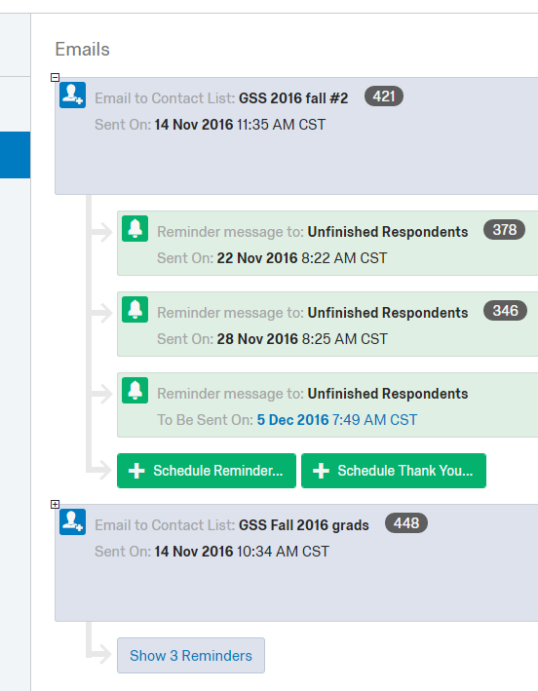
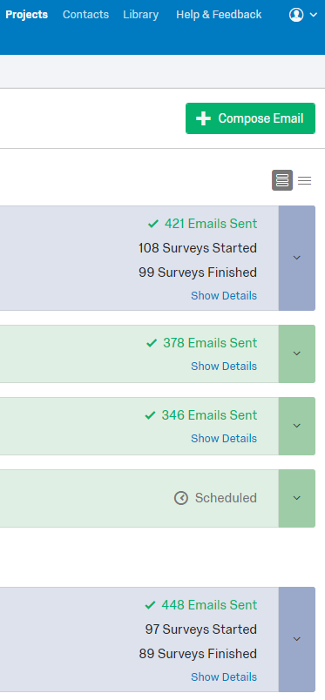

Another option for sending reminders is to click on the dropdown arrow and click the Schedule Reminder link.
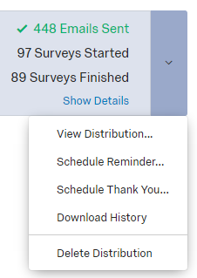

Reports
You can get the results of your survey in several different formats. Downloading a Qualtrics report is the quick way to get survey summary information.

On the Report page (see next page) in the far right hand corner are these options when you click on the down arrow for Report Options. Click the Export Report link, then the options appear. Select Word Doc.
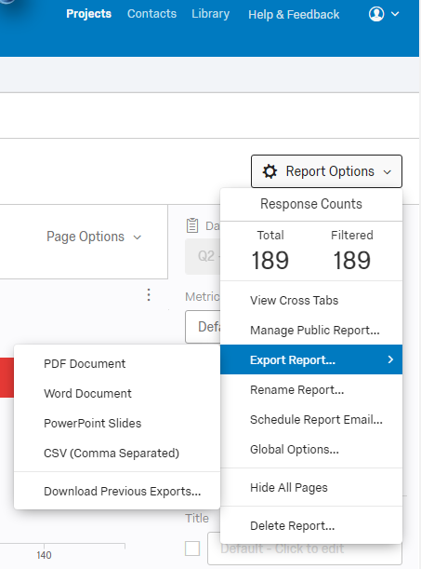
This is the left-hand side of the Reports page that opens on the Initial Report view.

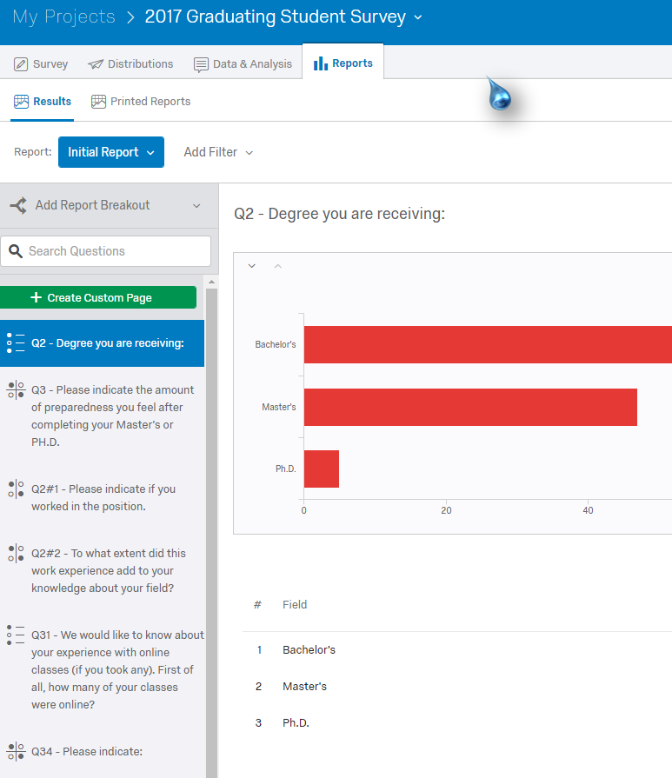
Parsing Results

In my surveys that have results by College, Department, Program, and Major, I produce reports for each of these areas. To get results for one of these areas, I add filters to the reports.

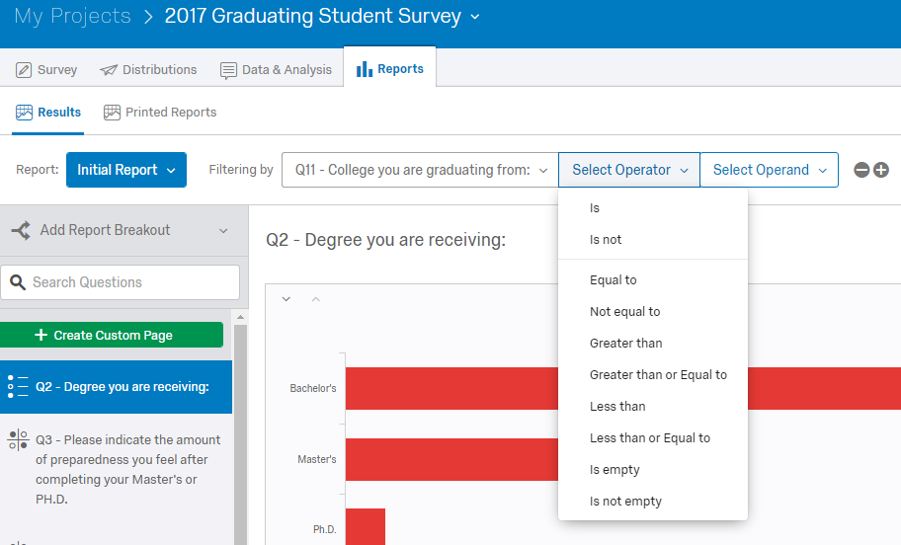

Select the question you want to filter by, and then use the drop down arrows to select the choices.

Proceed to download your report in the format you wish. You will need to label the report so you know what it is. The example on the next page is Word format. I replace Initial Report with the College or department name. The name and year of the survey show up as the title of my main survey. I also delete the time. Before I send out the reports, I also go through and delete the “statistics” that are meaningless such as the one in this example.

Field | Minimum | Maximum | Mean | Std Deviation | Variance | Count | Bottom 3 Box | Top 3 Box
Did your mother (or female legal guardian) graduate from college? | 1.00 | 2.00 | 1.67 | 0.47 | 0.22 | 42 | 100.00% | 100.00%

Example of the exported Word report:
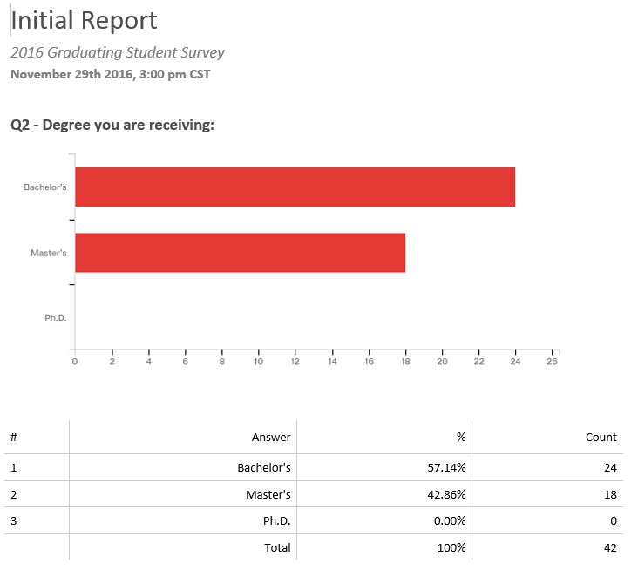
Downloading Data
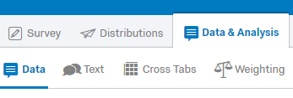 Then on right 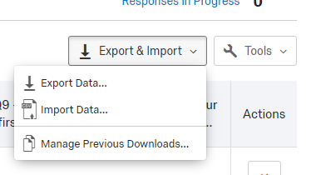
You will see this:
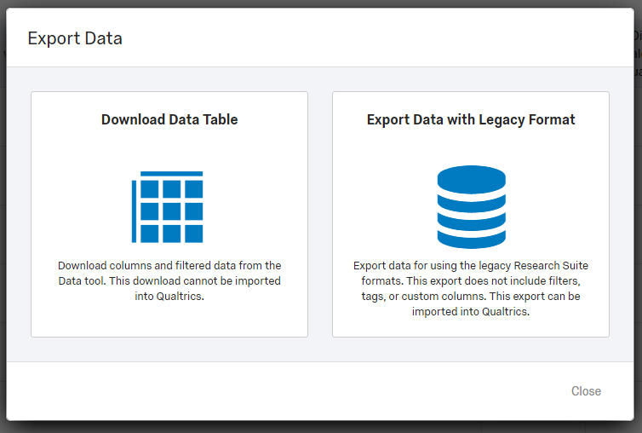

Then select your choice:
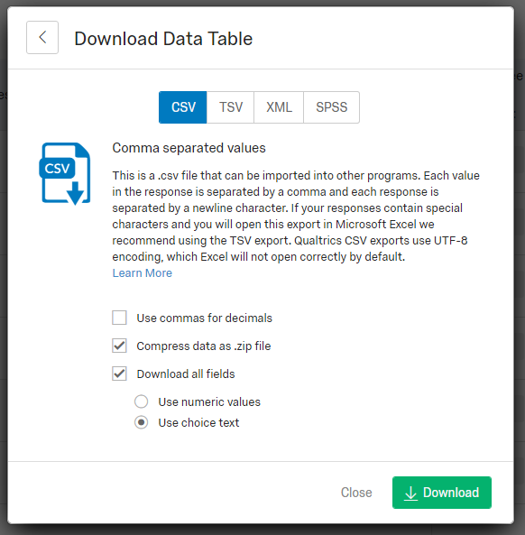
Libraries
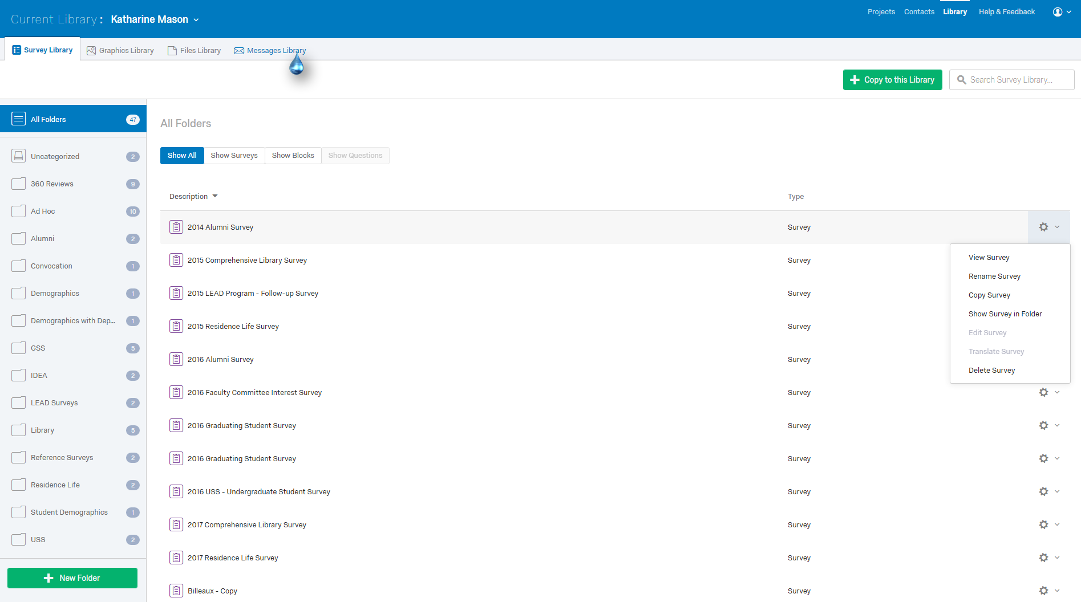

Close ups follow.

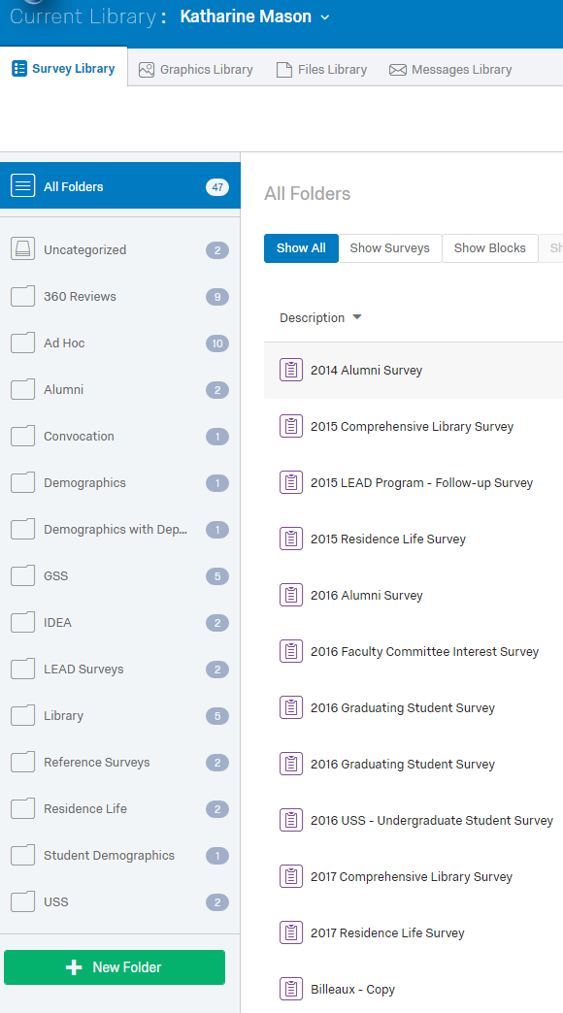
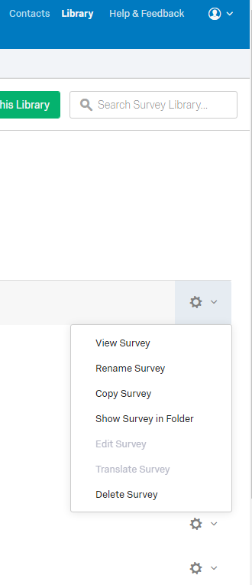

On the left you will see your surveys listed according to the folders you have named. On the right there are options for viewing, copying, and deleting. At the very top, above the options list is a green bar for copying (see next page).

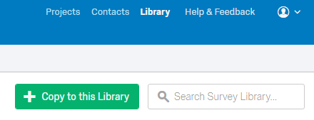

When you click on Copy to this Library, a dialogue box appears where you can select the source survey from your list of current surveys, assign it to a category, and rename it.

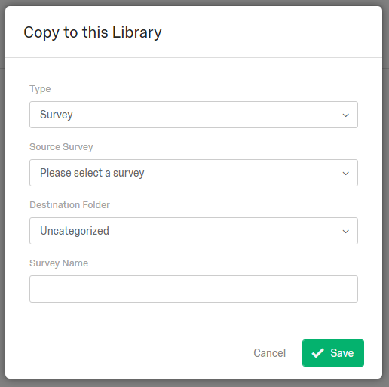

Of course this is not a problem until you have many surveys accumulated. Then you need to do some organizing. I always keep my data, but only the current version of a survey we are using. Visiting this Library helps keep things organized. I always check to make sure there is a copy of a survey before I delete it.

Page Breaks

If your survey is long, you can add page breaks. Remember, the progress bar lets respondents know how far along they are in the survey.
Select the question you want to insert a page break after. Go to the menu on the right side and click Add Page Break.
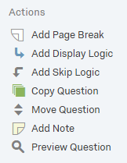

Housekeeping Issues
Renaming
To rename the survey, go to the dropdown arrow next to the present title.
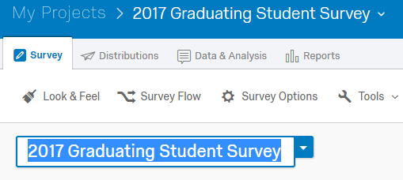 Put in a new title.
Renaming blocks works the same way: just click on the current title and change it to what you wish.
Deleting Responses
In the process of testing a survey, going into preview or sending it out for people to test, responses are recorded. When you are done with testing be sure to delete all responses that have been recorded during the testing phase.

Go here: then on right side Delete Responses

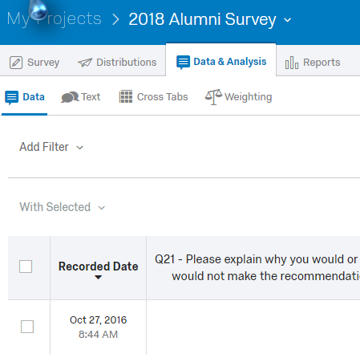
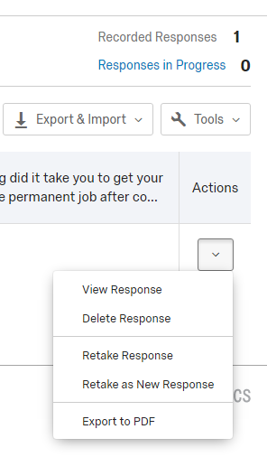

Just FYI…..
Punctuation Marks

[ ]
Brackets
( ) | { } | ⟨ ⟩
Round brackets or parentheses | Braces or curly brackets | Chevrons or angle brackets

Punctuation
apostrophe | ’ '
brackets | [ ] ( ) { } ⟨ ⟩
colon | :
comma | , ، 、
dash | ‒ – — ―
ellipsis | … ... . . .
exclamation mark | !
full stop, period | .
hyphen | ‐
hyphen-minus | -
question mark | ?
quotation marks | ‘ ’ “ ” ' ' " "
semicolon | ;
slash, stroke, solidus | / ⁄

Word dividers
interpunct | ·
space

General typography
ampersand | &
asterisk | *
at sign | @
backslash | \
bullet | •
caret | ^
dagger | † ‡
degree | °
ditto mark | ″
inverted exclamation mark | ¡
inverted question mark | ¿
number sign, pound, hash, octothorpe | #
numero sign | №
obelus | ÷
multiplication sign | ×
ordinal indicator | º ª
percent, per mil | % ‰
plus and minus | + −
equals sign | =
basis point | ‱
pilcrow | ¶
prime | ′ ″ ‴
section sign | §
tilde | ~
underscore, understrike | _
vertical bar, pipe, broken bar | | ‖ ¦

Intellectual property
copyright | ©
sound-recording copyright | ℗
registered trademark | ®
service mark | ℠
trademark | ™

Currency
generic currency symbol | ¤
currency symbols

₳ ​ ฿ ​ ₵ ​¢ ​₡ ​₢ ​ $ ​₫ ​₯ ​ ₠ ​€ ​ ƒ ​₣ ​ ₲ ​ ₴ ​ ₭ ​₺ ​ ℳ ​₥ ​ ₦ ​ ₧ ​₱ ​₰ ​£ ​ ៛ ​₽ ​₹ ₨ ​ ₪ ​ ৳ ​₸ ​₮ ​ ₩ ​ ¥
Uncommon typography
asterism | ⁂
hedera | ❧
index, fist | ☞
interrobang | ‽
irony punctuation | ⸮
lozenge | ◊
reference mark | ※
tie | ⁀

Related
- Other quotation styles (« » „ ”)

  - Diacritics
  - Logic symbols
- Whitespace characters
In other scripts
- Chinese
- Hebrew
- Japanese
- Korean
- Category
- Portal
- Book

