CUPA Administrative Salary Analysis for Your President

By : Dr. Allen Clark
aclark@unt.edu
University of North Texas

TAIR 30th Annual Conference
Galveston, Texas
Session: B5

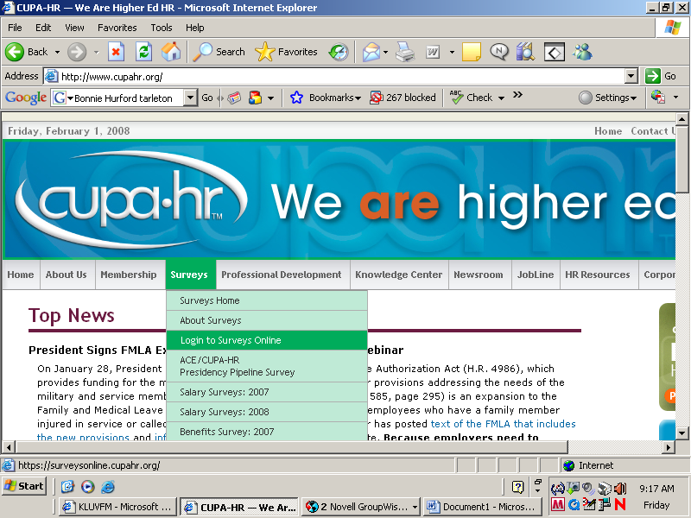

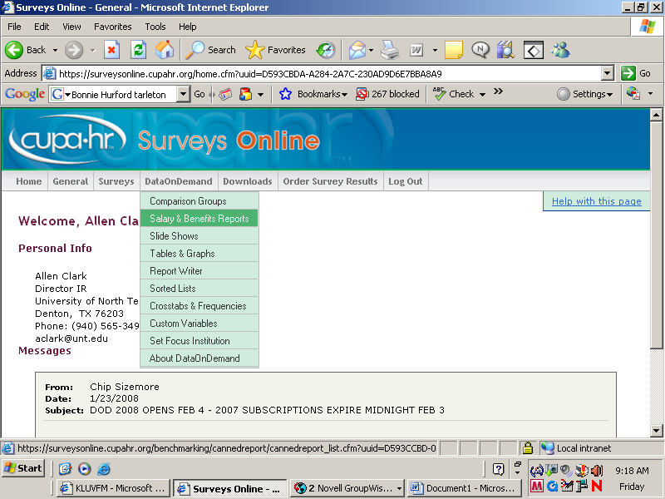

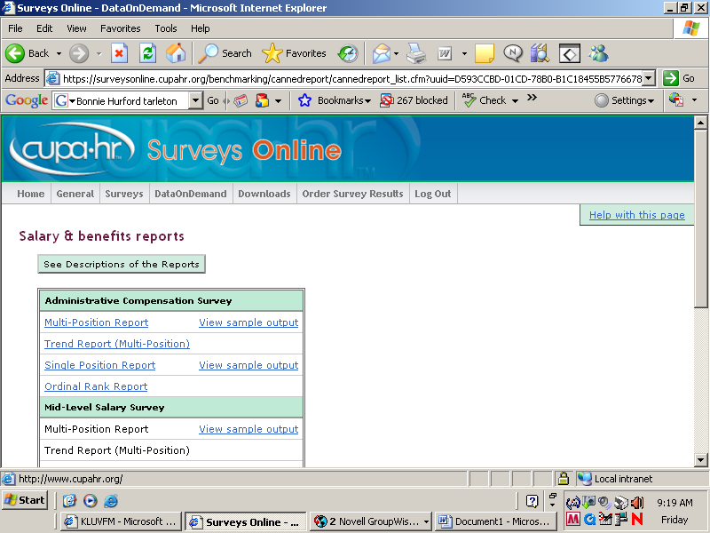

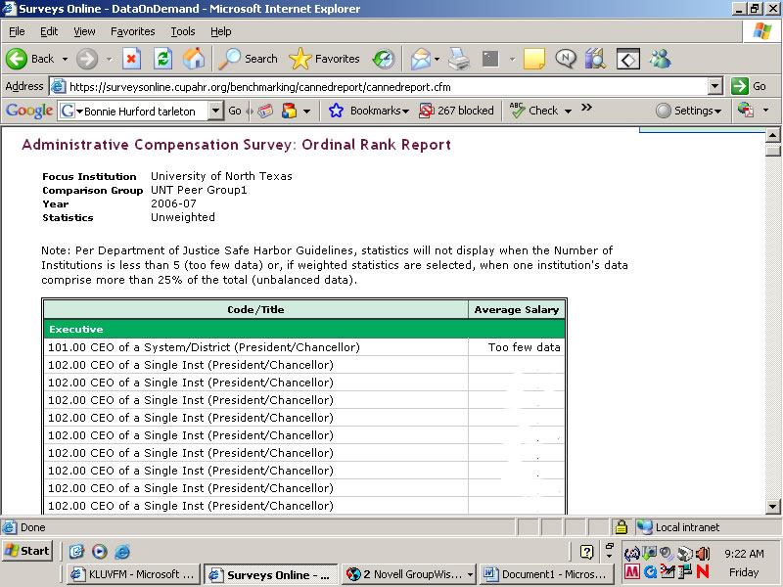

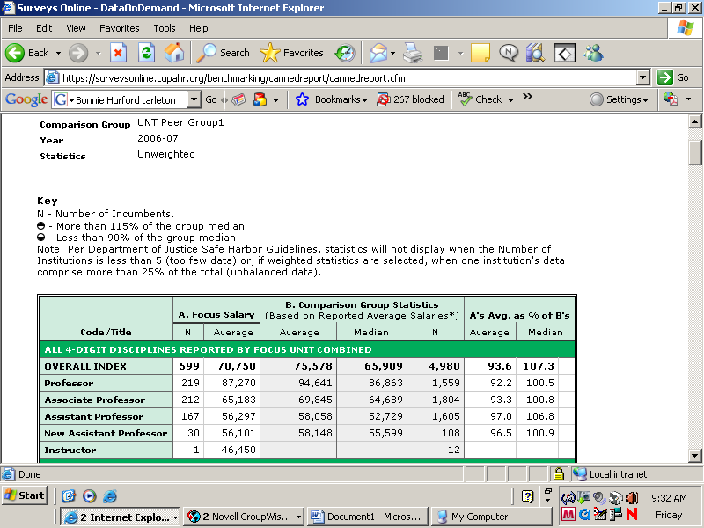
Source UNC:

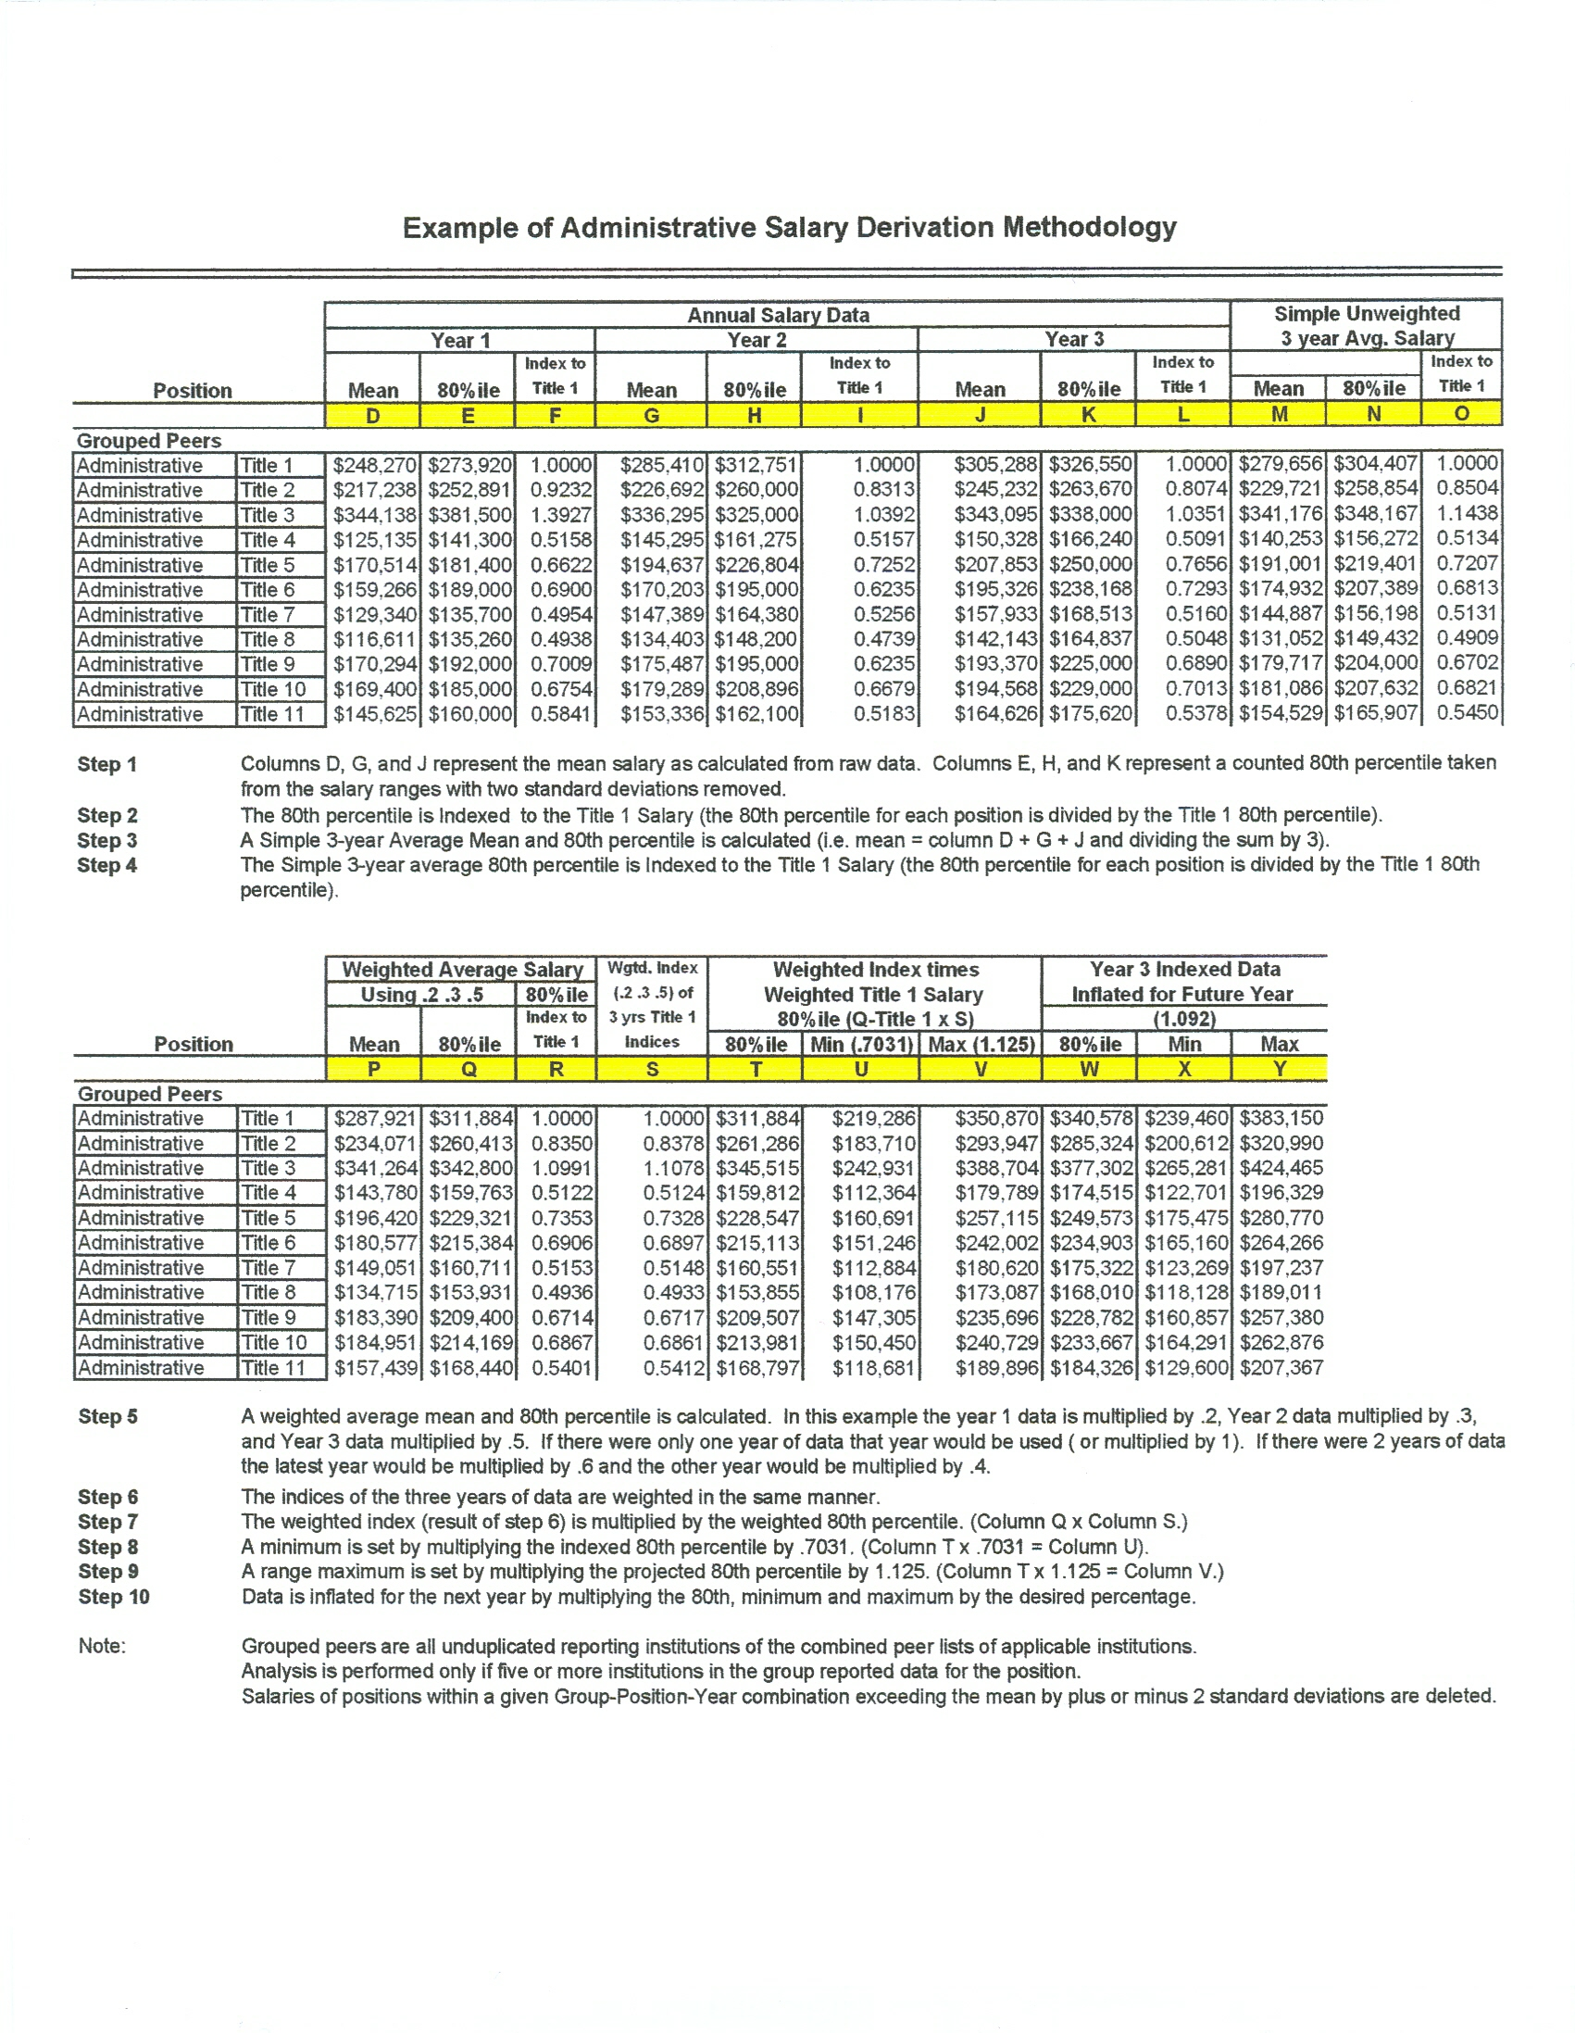
SAS Code:
Average:
PROC UNIVARIATE DATA=ADMIT_04;
VAR SALARY;
BY EXECUTIVE;
OUTPUT OUT=UNI04 MEAN=AVE04 MIN=MIN04 MAX=MAX04 PCTLPRE=PCNT04 PCTLPTS=80;
RUN;

Weighted Average:
DATA COMBINED_ADMIN2;
SET COMBINED_ADMIN;
IF AVE04 GT 0 AND AVE05 GT 0 AND AVE06 GT 0 THEN
WGHTD_AVE= .2*AVE04 + .3*AVE05 + .5*AVE06;
IF AVE04 GT 0 AND AVE05 GT 0 AND AVE06 GT 0 THEN
WGHTD_PCNT= PCNT0480*.2 + PCNT0580*.3 + PCNT0680*.5;

IF AVE04 = '.' AND AVE05 GT 0 AND AVE06 GT 0 THEN
WGHTD_AVE= .4*AVE05 + .6*AVE06;
IF AVE04 = '.' AND AVE05 GT 0 AND AVE06 GT 0 THEN
WGHTD_PCNT= .4*PCNT0580 + .6*PCNT0680;

IF AVE04 GT 0 AND AVE05 = '.' AND AVE06 GT 0 THEN
WGHTD_AVE= .4*AVE04 + .6*AVE06;
IF AVE04 GT 0 AND AVE05 = '.' AND AVE06 GT 0 THEN
WGHTD_PCNT= .4*PCNT0480 + .6*PCNT0680;

IF AVE04 GT 0 AND AVE05 GT 0 AND AVE06 = '.' THEN
WGHTD_AVE= .4*AVE04 + .6*AVE05;
IF AVE04 GT 0 AND AVE05 GT 0 AND AVE06 ='.' THEN
WGHTD_PCNT= .4*PCNT0480 + .6*PCNT0580;

IF AVE04 = '.' AND AVE05 = '.' AND AVE06 GT 0 THEN
WGHTD_AVE= AVE06;
IF AVE04 = '.' AND AVE05 = '.' AND AVE06 GT 0 THEN
WGHTD_PCNT= PCNT0680;

IF AVE04 = '.' AND AVE05 GT 0 AND AVE06 = '.' THEN
WGHTD_AVE= AVE05;
IF AVE04 = '.' AND AVE05 GT 0 AND AVE06 = '.' THEN
WGHTD_PCNT= PCNT0580;

IF AVE04 GT 0 AND AVE05 = '.' AND AVE06 = '.' THEN
WGHTD_AVE= AVE04;
IF AVE04 GT 0 AND AVE05 = '.' AND AVE06 = '.' THEN
WGHTD_PCNT= PCNT0480;

RUN;

Indexed Salary:

DATA COMBINED_ADMIN2;
SET COMBINED_ADMIN2;
MIN_RANGE=.7031*WGHTD_INDEX_PCNT;
MAX_RANGE=1.125*WGHTD_INDEX_PCNT;
RUN;
DATA COMBINED_ADMIN2;
SET COMBINED_ADMIN2;
PCNT_INDEXED=WGHTD_INDEX_PCNT*1.092;
RUN;
DATA COMBINED_ADMIN2;
SET COMBINED_ADMIN2;
MIN_INDEXED=MIN_RANGE*1.092;
MAX_INDEXED=MAX_RANGE*1.092;
RUN;

