Using Microsoft Access to Organize Institutional Research Offices
Abstract
Institutional Research offices are flooded with data requests daily, and keeping track of these requests can be a major concern in itself. Using Microsoft Access, the Institutional Research Department at Sam Houston State University has developed an all inclusive system that tracks requests, organizes syntax files, and updates the status of requests on the web. This system allows for less time tracking down data requests and more time analyzing data and writing reports. It is built in Microsoft Access so it is relatively easy to add features by using different tables, queries, and Visual Basic Macros to add functionality at limited cost.

An Institutional Research Organization System
8:00 AM; Monday morning the Vice President calls and needs the fall enrollment figures for the past six years
8:12 AM; while sorting through the data files the Faculty Senate representative emails about a request that was submitted two days ago asking for its status
8:22 AM; a student from Student Government drops by the office and would like to know how many seniors go to graduate school within a year of graduating
Just thirty minutes at work and three requests have come in…

While the above may be exaggerated (slightly) it does give a good representation of the morning of an analyst in the field of Institutional Research. Data requests come in all shapes and sizes, from various individuals, groups, and outside organizations. The question is, “How can we keep track of these requests without spending excessive amounts of time organizing, filing, and finding requests?” SHSU IR has developed an innovative and proprietary system using Microsoft Access to cut down the time it takes to get organized and thereby increase the time available to check, analyze, and report on the data requests that are received.
Our office organization system takes a data request through the entire life cycle, from request to reporting with a simple easy to use interface that has a relatively gentle learning curve. This system was implemented in 2003 and since then our data requests have increased dramatically, while our personnel have decreased, but through this system we have been able to keep all incoming requests organized. The current structure will serve as a model for what we eventually would like to be a completely web-based system where users will have the ability to track their request from start to finish, add comments along the way, and generally increase our visibility to the university through the web.

Some Background and The Process
Currently anyone may go to our website http://www.shsu.edu/oir/ and click on the Data Request link to submit a data request to our department. When a request is submitted an email is sent out to me, our administrative assistant, and the office email account so there are three copies. Previously we had considered carbon copying the request to the individual submitting the request, but we felt that this was a little impersonal; instead we opt to call the individuals to touch base with them and really get them involved with the request and ask key questions at this time. This process has really helped our office become more accessible. We do not want to be the department that simply works with data; we want to be the department that provides valuable information. This ensures that the requesting department will have accurate, accessible and timely information from the SHSU IR Department.

The Request Process
Once we receive an email, we enter the information into our request system by making a new request. When a request is entered into the system it is assigned a number such as IRD-05-040 which is our tracking system. IRD is for Institutional Research Department the 05 will be whatever year it is, and the 40 is the number of the request for that year. This numbering system allows us to correspond with the individual even if another person in the office is actually working on the request.
For each request, there is a folder on the SHSU IR Common Network share which is accessible only to SHSU IR employees and our student worker. Each time a request is generated a link is added into the request form that leads to that folder which contains the SPSS (or other) syntax, Excel sheets, Word documents, and any other items necessary to complete that task. For instance, if I was out of the office and someone was calling about a particular request I am working on, our administrative assistant can look up the request number (or name of person), click on the hyperlink to the folder, and take a look at what I have completed so far. This allows her to inform the requestor the progress on the report, instead of saying, I will have him call you back later, or I am not sure. This gives us more of a cohesive office whereby we all know what we are working on and what those around us are working on. Also, on the form are items such as the contact information, request description, action taken on request, and other items of use for each request. Any department employee can update the caller on the status of their request with a reasonable expectation of accuracy.

Past, Present, and Future…
The whole request system is easily searchable by keywords, which is a major time saver when we are looking for a request that we have done in the past and are not sure of the exact IRD number. All we have to do to find the particular request is search by any field that we know, such as the contact, the name of the request, the date it was done, or even the description of the request, among other items. When the request is found we can open the folder through the hyperlink and modify the syntax from last year to generate the report, a major time saver. Another benefit is if someone is looking for information on retention, for example, we can search for retention and find all the requests related to retention and provide the person with this information on the fly based on other reports. The power of having every request from the past years from a few mouse clicks has been revolutionary for our office.

Oh where oh where have my variables gone…?
When a new employee comes into an IR office it can be difficult to know exactly where to find obscure variables. A request may come in dealing with the number of students who have been involved in a specific type of orientation that has not been recently requested. The variable location system that has been built into the system reduces the amount of time the new employee spends searching for the variable, especially if the office is empty at the time. They can open up the system, click the “Find Variables” button and search for the name, description, or values of the variable much more efficiently than the old guess and check method. When a variable is found, the variable name, file it is in, description, and possible values are all displayed on a single easy to read form for location. This reduces the time it takes to find the variable, and also allows the new employee to find other files that may have the same or similar variables. We have several different datasets that we use on a regular basis, some with over 2000 variables included, without being able to search the system it would be much more difficult, and costly in terms of time, to find these variables, especially the obscure (we will never need that) variables.

The Log Files (what are we doing and what have we done?)
Originally we had our log file in an Excel document that was constantly being changed due to new requests, updating requests, and changing requests. With the system in place the database does all of the work. We simply update the form through the current request menu, and the log is automatically updated since it is a report generated by Access. The log contains all of the pertinent information as far as request title, contact, who is working on the request, and a timeline of when it was requested and when it is due. The current log contains only the files that are currently in progress by using a query on the status of the request. Each week a copy is brought to our meeting and each of the current requests are discussed and updated if necessary through the request system.

In addition to the current log we have split up the log files by year to predict when certain surveys will come in for the next year and to see how many requests we have as compared to the same time the year before. Previous log files are also printed out on occasion to go over requests that might have been done years ago that we would like to update and compare with the previous report. Another benefit of these logs are that when someone calls and says “In 2002 you did a report on X for me, do you have that?”, and we can print or check our log from 2002, find the IRD number and send them the PDF within minutes. This is a quick way to find our older reports which may not be hyperlinked through the system.

The Status Update
Riiiing Riiing “How is my request coming?”. How many times do you hear this? Many times a day we used to receive these types of calls which lead to several minutes of explanation, messages, and unnecessary time explaining where the request was on the assembly line. The status update has dramatically reduced these types of calls. When a request is entered it automatically receives a “Received” status and is uploaded, through Access, to our reporting schedule (http://www.shsu.edu/~ird_www/cgi-bin/datarequest/reporting-schedule.cgi) on the web where they can see what stage the request is in. This way they can check our website to see if a request is near completion (“Finalizing”). The other categories are “In Progress”, “On Hold”, or “Cancelled”. In Progress means we are currently working on the request, this way they know it has been started. On Hold means we have contacted them and could be waiting on information for the request to begin processing. Cancelled means we have contacted them and they have probably said they do not need the information, or it will be processed by another office. Cancelled and Returned are the only categories from the request system that do not appear on the reporting schedule because they have been finished processing. The status update has really helped us keep on track and know where each request is, but more importantly it helps keep the customer informed throughout the process.

The Syntax Library
This is one of our lesser used, but important features in the system. The syntax library allows us to take our syntax for any of the requests we are currently working on or have previously worked on and have them at our finger tips. It especially helps when we have a very complex syntax that we have spent a lot of time and effort on and do not wish to generate again. The syntax library is searchable by IRD number, Syntax Title, and description of what the syntax actually does. For instance, if we had to calculate the number of students in Introduction to Computer Science by major, ethnicity, gender, GPA, hours enrolled, hours completed, etc. This same report had been requested two years earlier and so we search the syntax library and viola there it is. The syntax is hyperlinked so we open it up and modify it for the current year, run it, check the data and write the report. Instead of rewriting the syntax from scratch, a simple adjustment was made to produce the report for the current year. The syntax library can also work with other files such as Perl, SQL, SAS, and any other files since they are simply linked from the system.

Requirements of the system
The requirements of the system as we have it set up now are Microsoft Access, a shared network drive, and a web page with Perl (CGI) ability. There is some knowledge required about Access programming to maintain the system, but eventually the year to year updating will be done automatically to save time. It is good to have a background in Computing Science so that some of these things can be implemented more easily on your own system, but it is not absolutely necessary.

Limitations
There are some limitations that are important to discuss, mostly in the year to year updating. When the New Year arrives there are five or six items that must be done to adjust the IRD numbers, since it is not automatically done. There are some minor things that must be updated from year to year, but the time it takes to update these items is more than made up for in the time saved throughout the year by using this system. This is a custom made system tailored to our network so there are many things that will not work with other network setups, but as stated before with limited Access programming knowledge these can be easily adjusted.

Future Versions
As the Internet and Intranets are increasingly easier to program on, a future version will be completely web based from start to finish. The hyperlinks will still go to our internal shared drive, but customers should be able to have more access to their request, such as securely downloading their reports (as opposed to email), checking out comments that we make through the process, and using an online submission form to request more information based on their request. A web based system would eliminate the need to have Microsoft Access as the back end and would use a server side database client to store the information.

Conclusion
Many of these items are probably things that are set up in your office right now. They may be in separate programs, on paper, or in various other filing systems. This system takes all of these items and combines them into a user-friendly IR organization system which has saved our office countless hours and allowed us to get and stay organized even as our requests continue to increase. I hope I have generated some interest in this area so that other offices may develop and implement their own systems to increase their productivity, thereby providing more to the universities that they serve. The most important thing in this type of system is that it should be user friendly, otherwise it will take more effort to keep up with the system and the time savings benefits will be outweighed by the frustration of trying to figure out the system. I hope some ideas have been generated in reading this and from the presentation. Feel free to contact me with comments, suggestions, and ideas.
Brian Cordeau,
Sam Houston State University
Office of Institutional Research
936.294.3619 or brianc@shsu.edu

Appendix A Figures 1 - 5
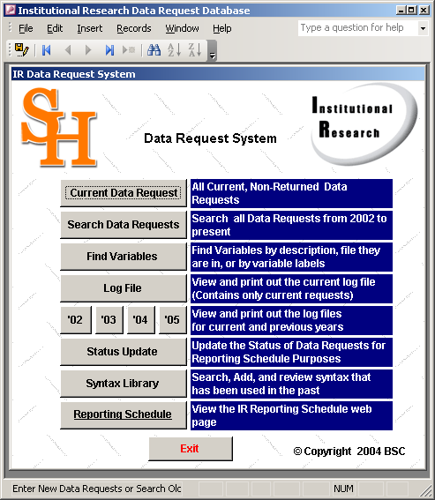
Figure 1 - Data Request Menu

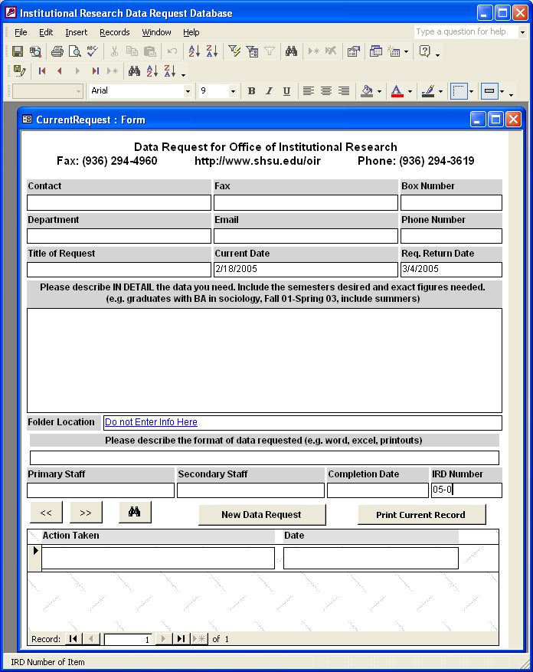
Figure 2 - The Request Form

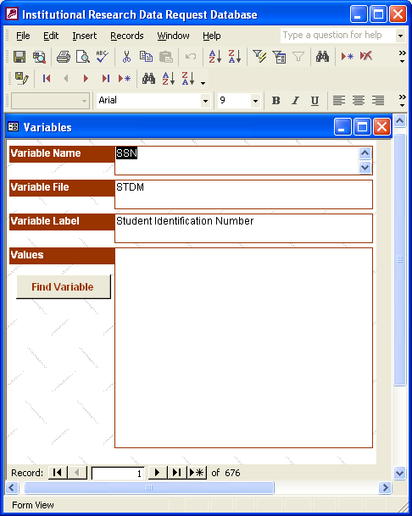
Figure 3 - The Find Variables Form
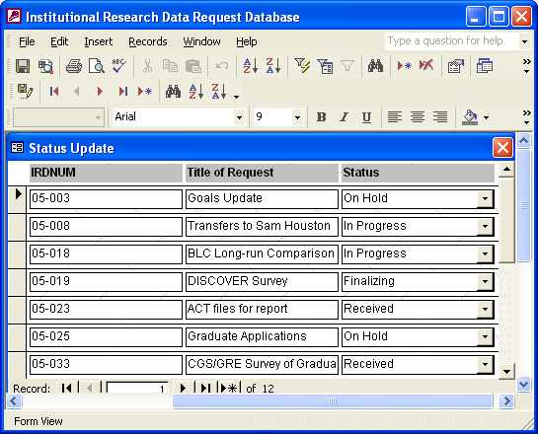
Figure 4 - The Status Update Form
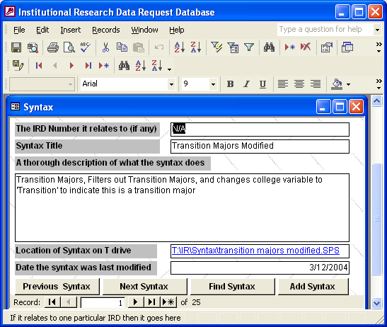
Figure 5 - The Syntax Library Form

